Words that goes together
Ex.1
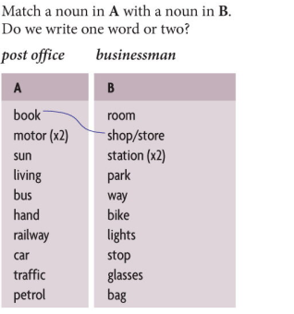
Ex.2
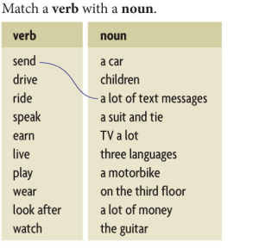
Ex.3
Make up 10 sentences using modal verb CAN/CAN’T/COULD/COULDN’T and word combination from 1 and 2 exercises.

Ex.4
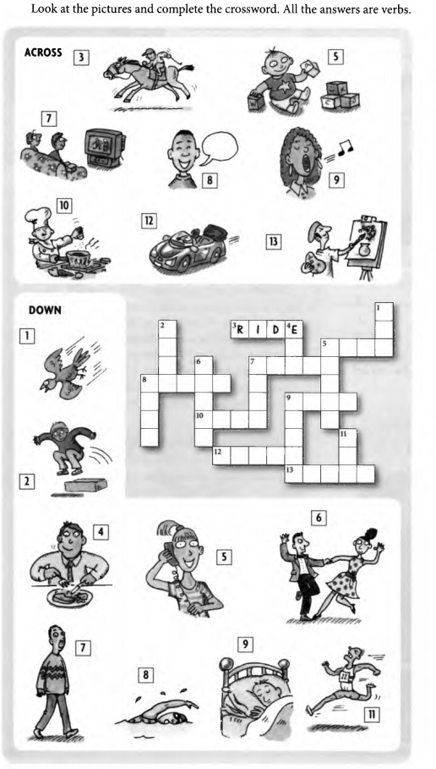

Ex.5 Answer the following questions
